

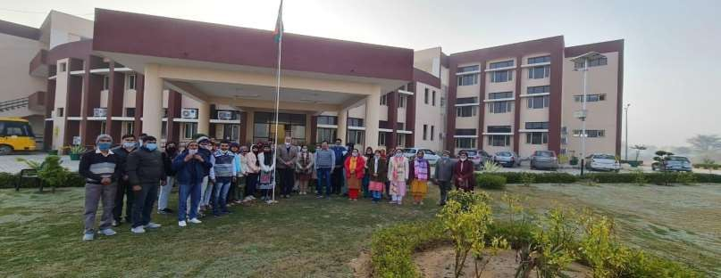GOVERNMENT COLLEGE FOR WOMEN, PALI

(REWARI)

ANNUAL REPORT SESSION 2024-25

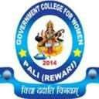

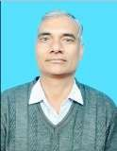

Message

It gives me immense pleasure to bring out College Annual Report for the session 2024-25. The college Annual Report is a very important document which acts as a repository of all the activities of an institute and showcases its achievements and capabilities. Along with this function as an evidence of what has been done and where we lack, the Annual Report, implicitly, is also about where the institute seeks to stand in the coming future. It is this combination of the present and the future which makes Annual report a vibrant document and an invaluable part of all academic lives.

Government College for Women, Pali, through situated in the rural hinterland and functioning with a small strength of nearly 300 students, has a lot more to it than mere numbers and location. The college is part and parcel of the rising aspirations of rural girls to achieve education as part of their efforts to rise beyond their humble beginnings. They might not have received school education in costly private schools and their parents may not be rich enough to send them to far- off universities, but their aims and determinations to rise in life are not humble. The students of this college participate enthusiastically in all the activities of the college as the Annual Report makes evident. The passion, the determination and

the grit to go beyond the shackles of the poor beginnings and present obstacles makes these students fair example of what we can achieve in our lives through commitment and perseverance .

My congratulations to all the students, staff members and particularly editorial board of Annual Report (2024-25) to bring out this valuable document and become part of the journey of this great institute.

Warm regards Sincerely Dr. Karan Singh

**Students during the Session (2024-25)**

B.A.= 219, B. Sc= 57, B. Com= 28, B.A. (Honours)= 25,

M. Sc (Computer Science)= 25:

Total=354**er**

**Our Stars**

**B.A. VI Semester**

|  |  |  |  |  |
| --- | --- | --- | --- | --- |
| Sr No | Name of the student | Father’s Name | Marks Obtained | Position and Percentage |
| 1 | Parita | Bikesh | 1849/2400 | Ist, 77.04 |
| 2 | Khushbu | Ajit Singh | 1821/2400 | 2nd, 75.88% |
| 3 | Preeti | Krishan Kumar | 1761/2400 | 3rd,  73.38% |

**B. Sc VI Semester**

|  |  |  |  |  |
| --- | --- | --- | --- | --- |
| Sr No | Name of the student | Father’s Name | Marks Obtained | Position and Percentage |
| 1 | Neha | Mukesh Kumar | 1926/2900 | Ist, 66.41% |
| 2 | Kalpana Yadav | Raj Kumar | 1785/2900 | 2nd, 61.55% |

**B. Com VI Semester**

|  |  |  |  |  |
| --- | --- | --- | --- | --- |
| Sr No | Name of the student | Father’s Name | Marks Obtained | Position and Percentage |
| 1 | Saniya | Raj Kumar | 2070/3600 | Ist, 57.5% |

**Results of the College**

The results of most of the classes in the college are better than University pass percentage. The class-wise results for the session 2024-25 (declared) as on April 2025 are as follows:

|  |  |  |  |
| --- | --- | --- | --- |
| Class | College Pass percentage | University Pass Percentage | Difference |
| B.A. I Sem | 32.93 | 16.15 | 16.78 +ve |
| B. Sc I Sem | 50.00 | 19.60 | 30.4 +ve |
| B.A. III Sem | 21.54 | 17.24 | 4.3 +ve |
| B.A. V Sem | 38.37 | 35.79 | 2.58 +ve |
| B. Com III Sem | 50.00 | 26.16 | 23.84 +ve |
| B. Com V Sem | 33.33 | 43.65 | 10.32 -ve |
| M. Sc. III Sem | 25.00 | 25.00 | 0 |
| B. Sc III Sem | 57.89 | 37.33 | 20.56 +ve |
| M. Sc. I Sem | 50.00 | 55.45 | 5.45 -ve |
| B.A. I Sem (Honours) English | 32.93 | 16.15 | 16.78 +ve |

**National Service Scheme Report (2024-25)**

**GOVERNMENT COLLEGE FOR WOMEN, PALI**

The National service Scheme (NSS) is a central sector scheme of Government of India, Ministry of Youth Affairs & Sports. It provides opportunity to the students to take part in various government led community service activities & programmes. The sole aim of NSS is to provide hands on experience to young students in delivering community service.On 1st August, 2017 NSS unit was started with 100 volunteers in Govt. College for Women Pali, Rewari. Two types of activities are conducted in NSS- Regular activities (120 hours) and Annual Special Camp (120 hours). All the volunteers have to serve in NSS for at least 2 years for 240 hours to get certification from the university under the signature of Vice Chancellor and programme coordinator.

* Cleaning
* Awareness Programs on social issues, social problems, education and cleanliness
* Awareness Rallies
* Health Camp
* Poster Making, Slogan Writing, Essay writing, Declamation on different topics to spread awareness among students.
* One day Camp
* Special 7 days Camp

In this current session (2024-25) the NSS volunteers have participated in following activities:-

|  |  |  |
| --- | --- | --- |
| **Sr. No.** | **Date of the Program** | **Description of the  Program** |
| 1 | 12.08.2024 | Har Ghar Trianga Campaign |
| 2 | 12.08.2024 | Drug Abuse Prevention Campaign(Oath and Tree Plantation) |
| 3 | 15.08.2024 | Celebration of Independence day |
| 4 | 9.09.2024 | Slogan and Poster making on drug Abuse Prevention |
| 5 | 10.09.2024 | Seminar on Drug abuse Prevention |
| 6 | 24.09.2024 | NSS Orientation |
| 7 | 11.10.2024 to 17.10.2024 | Participation of Volunteers in NIC Camp Hissar |
| 8 | 15.11.2024 | Release of Haryanvi movie Parvarish for Youth Festival |
| 9 | 18.11.2024 | NSS One Day Camp |
| 10 | 20.11.2024 | Extension lecture on drug Addiction |
| 11 | 17.01.2025 | Reading of Preamble of India |
| 12 | 18.01.2025 | NSS One Day camp |
| 13 | 21.01.2025 to 27.01.2025 | Participation of NSS Volunteers in university Level camp at GCW Narnaul |
| 14 | 24.01.2025 to 30.01.2025 | NSS Special Seven days Camp |
| 15 | 26th Jan. 2025 | Dance, Poem & Speech on Republic Day Programme |
| 16 | 6.03.2025 | One Day NSS Camp |
| 17 | 8.03.2025 | Women Day Celebration |
| 18 | 19.04.2025 | Celebration of Poshan Pakhwara |
| 19 | 6,12 &21 .06.2025 | Celebration of International yoga Day |

**Special 7 days Camp**

A Seven Day Camp of NSS was organized in the month of Jan from 24th  to 30th Jan. 2025. A Total 50 Volunteers participated in this camp. During the camp following activities were conducted: -

Inauguration of camp was done by Principal Dr. Karan Singh on 24.01.2025  at Community Centre Gothra Village. Volunteers participated in ‘Best Out of Waste Material’ .The theme of Poster Making activities was ‘Beti Bacho Beti Padao’  Voters Day & ‘Say No to Tabacco’. Rally was organized to aware villagers about the harmful effects of Tabacco and to promote the Campaign ‘Beti Bacho Beti Padao’. Surya Namashakar was done every day in morning  session.  On the last day Best Volunteer of NSS Camp was selected and all students were awarded with camp certificate by Dr. Karan Singh, Principal, GCW Pali.

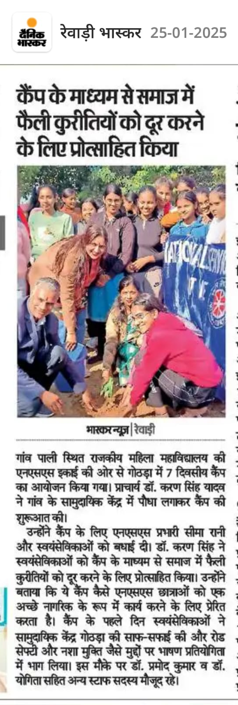

**Youth Red Cross Activity 2024-25**

**Govt. College For Women,Pali**

|  |  |  |
| --- | --- | --- |
| S.No | Date Of Event | Activity |
| 1 | 10.09.2024 | Intra College Seminar on” Drug abuse Prevention” |
| 2 | 18.09.2024 | Celebration of National De- Worming Day |
| 3 | 24.09.2024 | Celebration of National Mop up Day |
| 4 | 5th Feb. to 10th Feb. | Participated in State Level Youth Red Cross Training Camp |

**Youth Red Ribbon Club Activity 2024-25**

**Govt. College For Women,Pali**

|  |  |  |
| --- | --- | --- |
| S.No | Date Of Event | Activity |
| 1 | 31.01.2025 | Volunteers attend Training on HIV/AIDS at sandpiper Tourist Complex |
| 2 | 03.02.2025 | Various competitions i.e. Slogan Writing, Poster Making, Speech Competition organized under RCC |
| 3 | 12.04.2025 | Celebration of World Health Day |

**CULTURAL ACTIVITIES**

From 14-16 November 2024, Department of student welfare IGU Meerpur organized a youth festival ‘’HINDOLA 4.0.’’ In this festival 25 students participated in 15 events. Students got 2nd position in Hariyanvi short film. Student Neha Bhardwaj got 3rd position in Sanskrit Shlok Ucchharan.

**List of participants of Haryanvi short film:**

|  |  |  |  |  |  |
| --- | --- | --- | --- | --- | --- |
| 1 | Usha | ghanshyam | b. a 1st | 5051 |  |
| 2 | Nancy | Pradeep kr | b.sc 2nd | 1230255003 |  |
| 3 | Neha | Bijender kr | b.a 1st | 1230245028 |  |
| 4 | Priya | sumer singh | b.a 1st | 5006 |  |
| 5 | Divya | Narender singh | b.a 1st | 5033 |  |
| 6 | Lalita | shripal | b.a 3rd | 221171101020 |  |
| 7 | Diksha | rajesh | b.a 3rd | 221171101029 |  |
| 8 | Ratna | yashpal | b.a 2ndhon | 1232574011 |  |
| 9 | kanchan | satender | B a 3rd | 221171101013 |  |
| 10 | himanshi | shishram | b.a 3rd | 221171101031 |  |

List of participant of Declamation

|  |  |  |  |  |  |
| --- | --- | --- | --- | --- | --- |
| Sr.no | Name | f. name | Class | Roll no |  |
| 1 | Neha | Bijender kumar | B.A. 2nd | 1230245028 |  |

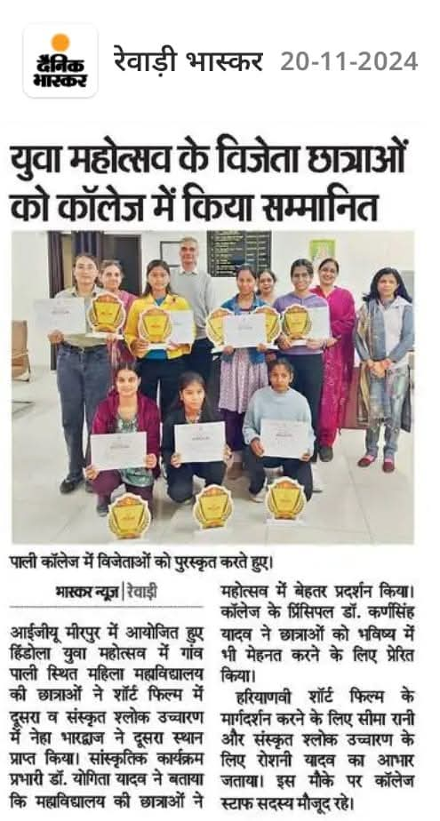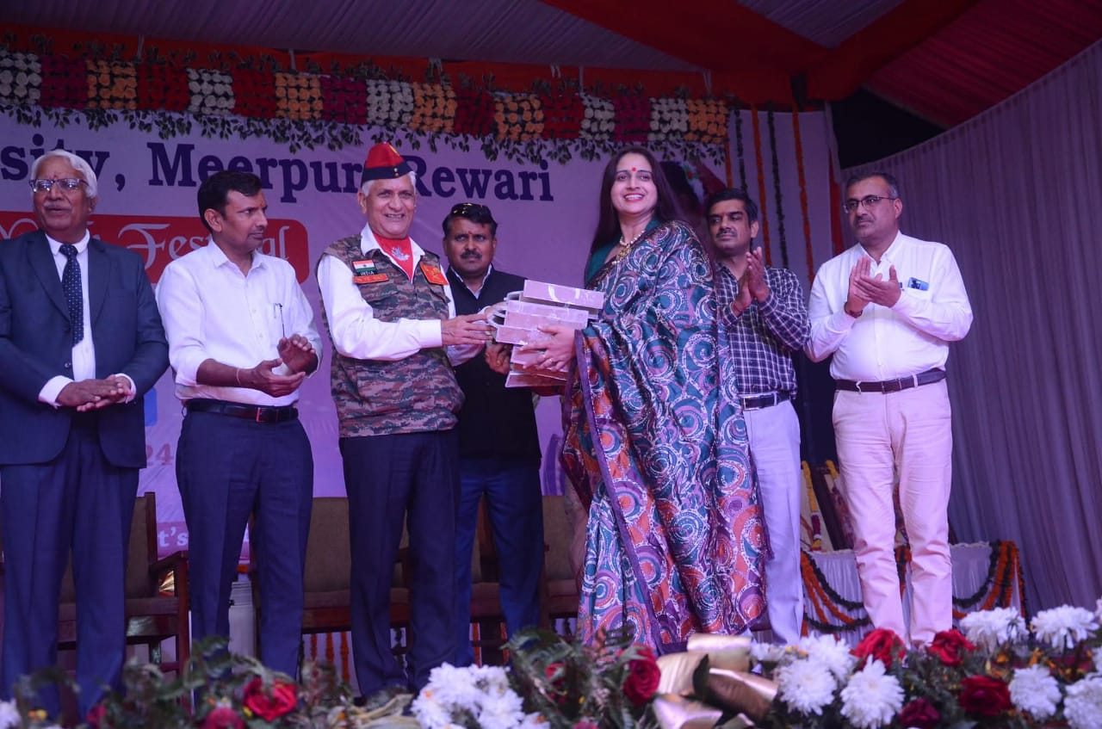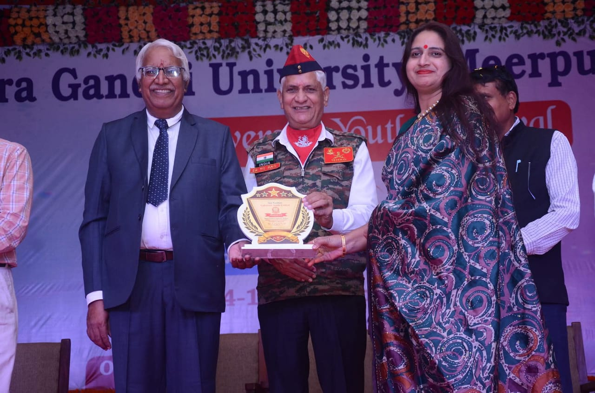

**Cultural festival**

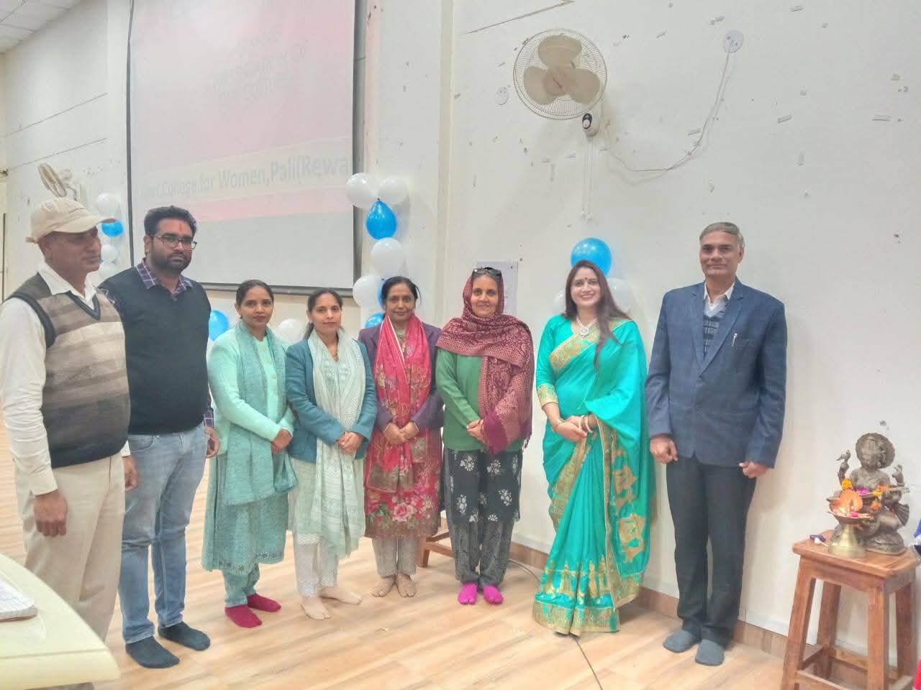

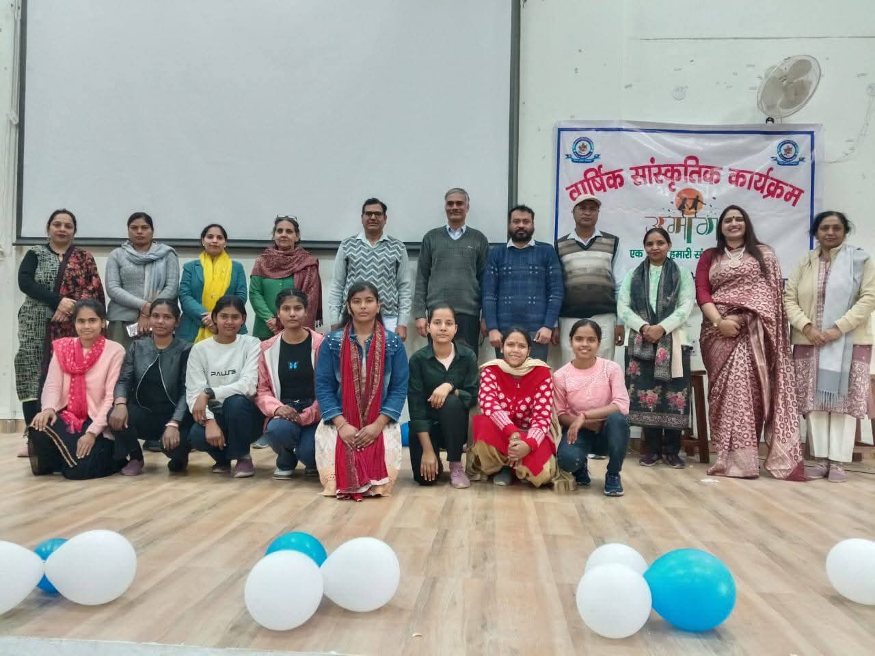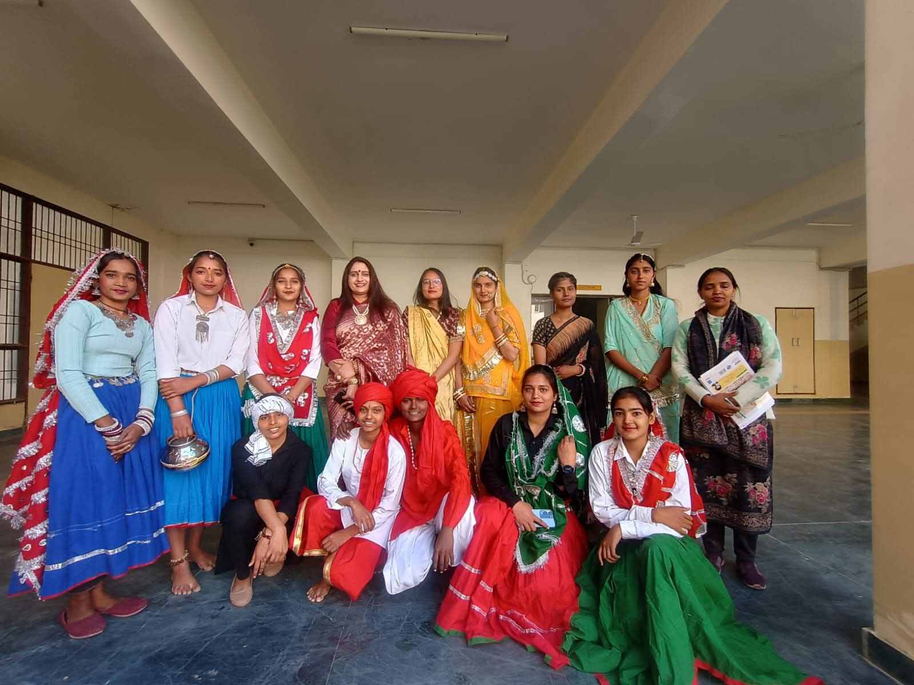

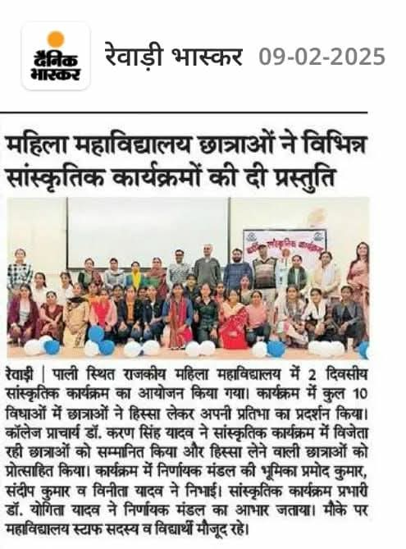



**Placement cell**

An extension lecture was organized on 21-01-2025 under Placement Cell in collaboration with English department. The lecture was delivered by Dr. Dalbir Singh, Director, RDS College, Rewari on the topic “Resume Writing and interview Skills” before the students and staff members of the college.

**Activities undertaken by Women Cell**

**Mehandi competition**:-On 19th Oct, 2024 Mehandi competition was organized under W.S.D.C on Karwa Chauth under the inchargeship of Mrs. Roshni Assistant Professor of Hindi. Ten Students participated in the competition and display their art with the beautiful, attractive and traditional designs. The judgement committee included Dr. Yogita Yadav, Dr.Ritu Rani, and Ms. Vinita as its members. The List of Position holders is as:-

|  |  |  |  |
| --- | --- | --- | --- |
| Name | Class | Roll No | Position |
| Muskan | B.A. 3rd | 2061 | 1st |
| Himanshi | B.A. 3rd | 2031 | 2nd |
| Divya | B.A. 1st | 5033 | 3rd |

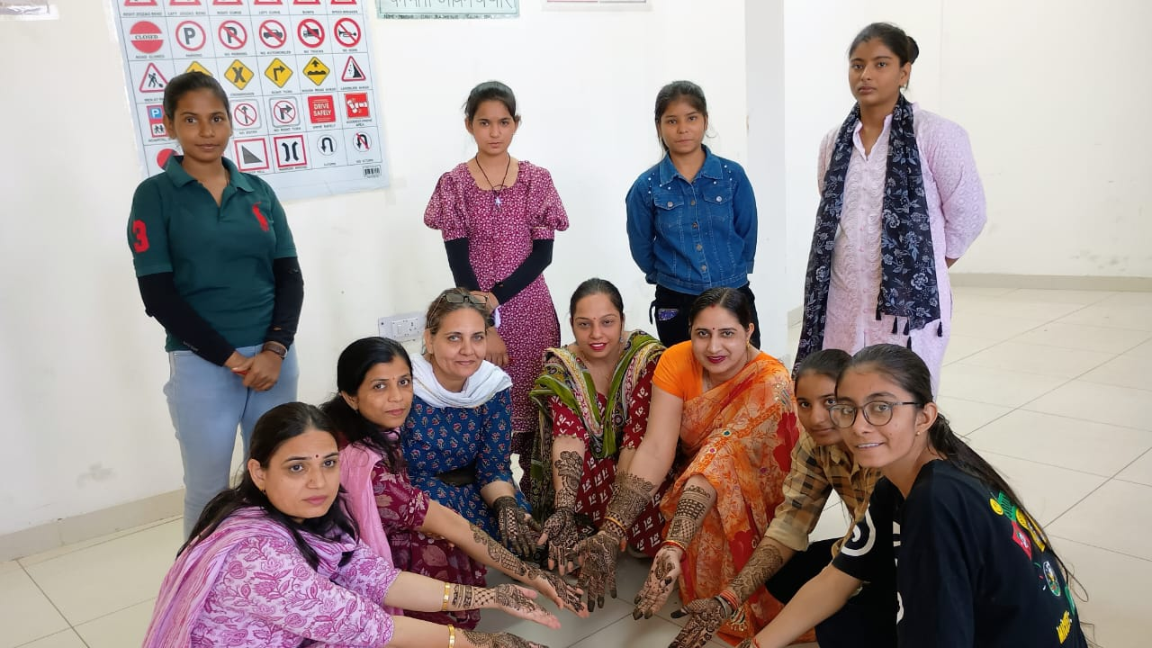

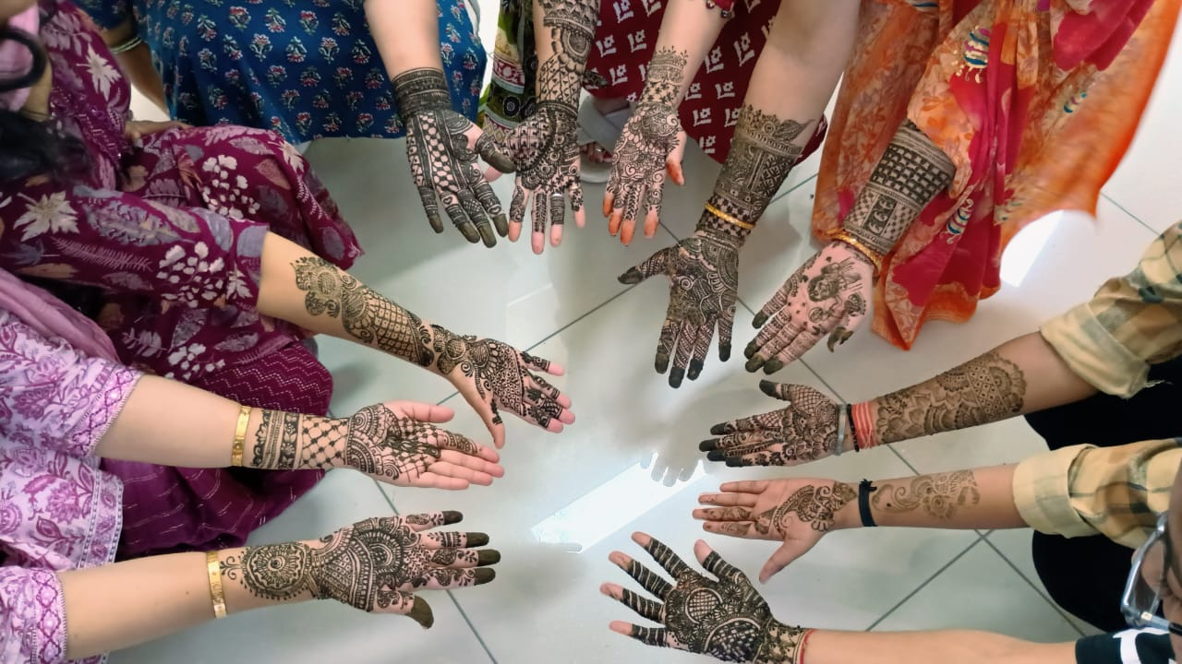

**Extension lecture:**  An extension lecture was organized on the topic “The Importance of Gender Sensitization.” Dr. Priyanka Lamba, Professor Department of English, Dronacharya Government College, Gurugram was the resource person of the day.

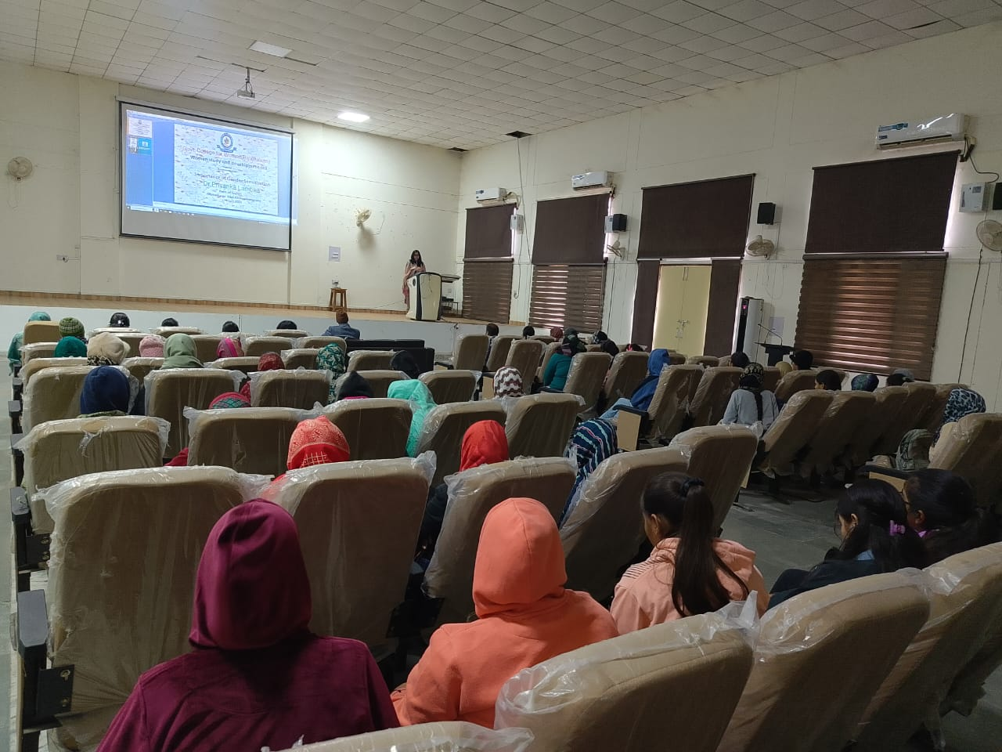

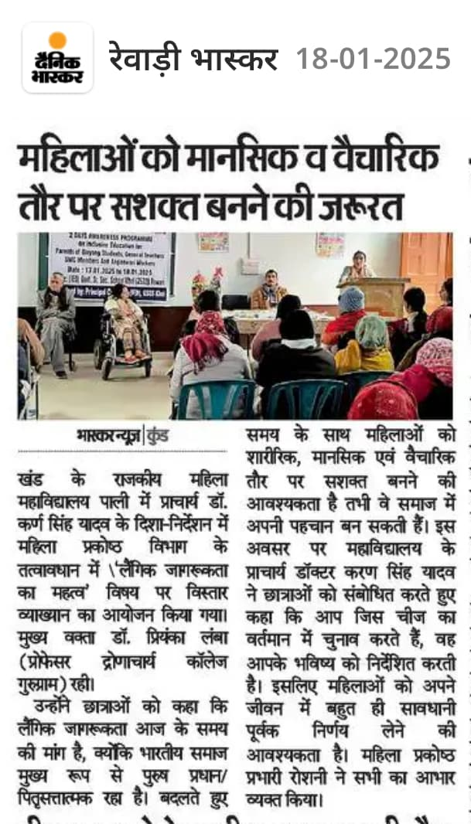

**Extension lecture: An extension lecture on the topic** “Today’s Woman: Her Challenges, Opportunities and Responsibilities” was delivered by Dr. Snehsata, Associate Professor, Department of English, Central University of Haryana, Jat Pali Mahendergarh.

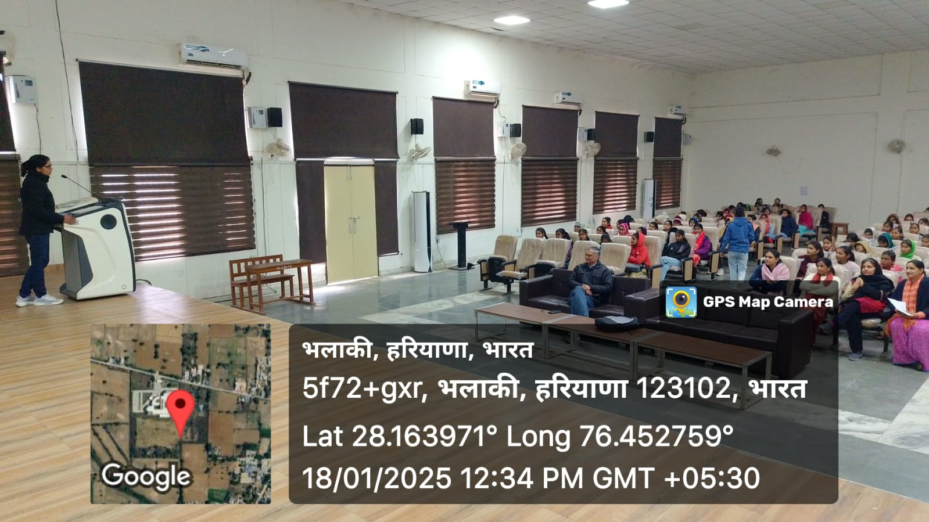

Essay writing competition on the topic of “**women empowerment” on 20.01.2025.** The List of Position holders is as follows:

|  |  |  |  |
| --- | --- | --- | --- |
| Name | Class | Roll No | Position |
| Neha | B.A. 2nd | 5028 | 1st |
| Khushbu | B.A. 3rd | 2055 | 2nd |
| Manisha | B.A. 2nd | 5008 | 3rd |

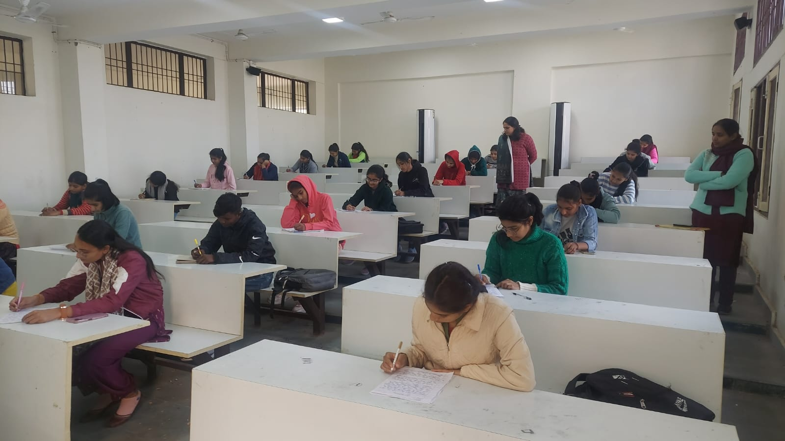

**Four day’s self Defense training** was organized under W.S.D.C. from 27.01.2025 to 30.01.2025 under the inchargeship of Mrs. Roshni . Sh. Deepchand from District Sports Taekwondo Association Rewari was the trainer of this training. Total 60 students participated in this training to learn about various techniques for self defense in case they are trapped in an undesirable situation.

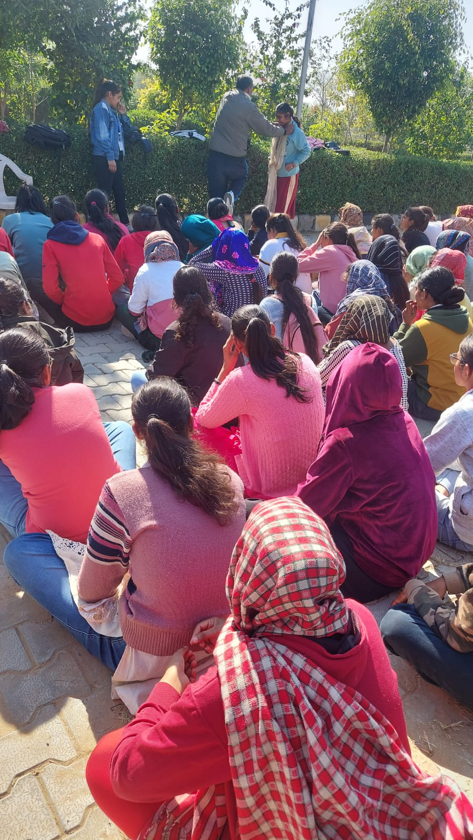

**Speech making competition** was organized by W.S.D.C in collaboration with N.N.S. on the topic “**women empowerment”** on 8th March 2025 on occasion of International Women’s Day In which 19 students participated.

The List of Position holders is as:-

|  |  |  |  |
| --- | --- | --- | --- |
| Name | Class | Roll No | Position |
| Neha | B.A. 2nd | 5028 | 1st |
| Khushbu | B.A. 3rd | 2055 | 2nd |
| Manisha | B.A. 2nd | 5008 | 3rd |

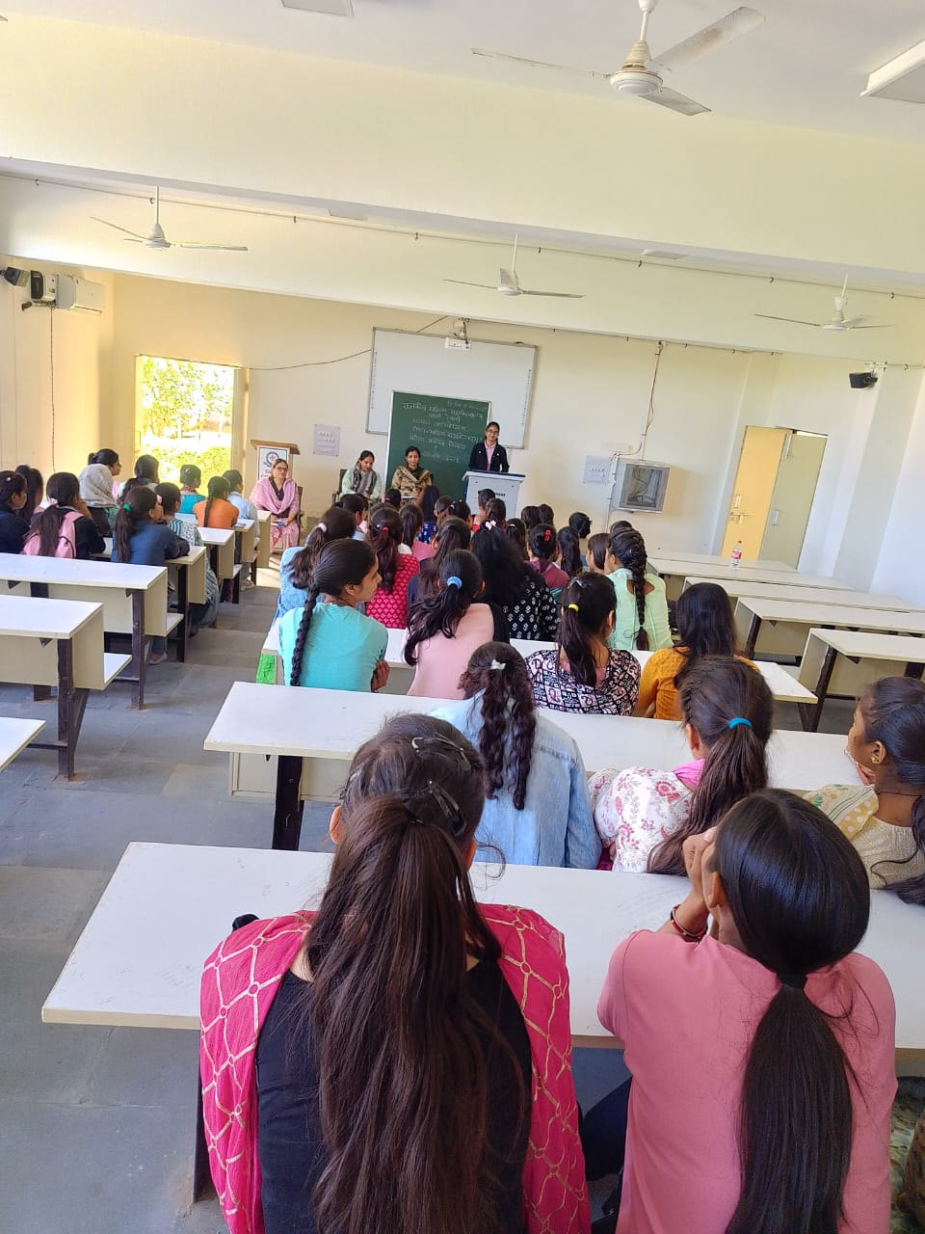

**Library**

The library caters to the needs of open the horizons of knowledge of teachers and students by providing access to books and journals on respective subjects, general awareness books, biographies and autobiographies of great leader, saints and social workers, popular novels, story books, newspapers, magazines, periodicals etc. It inculcate the habit of reading and learning among the teachers and students which further not only update their knowledge but also increase their power of critical thinking and creativity.

* A reading hall with 12 Reading table, 90 Chairs, 02 Magazine stands and 03 News Paper stands has been provided within the library where users can read books, magazines and newspapers. Library issues books to students and teachers as per their needs.
* Now library of this college is fully automated which provides a facility of easy access of books. Internet facility is provided in the library.
* 03 Photocopiers and 03 Printers also have been provided in the library.
* A good number (3414) text books and reference books are kept in this library for reading and learning of students and teachers.
* Four dailies- The Hindu, Amar Ujala and Dainik Bhaskar Tribuneare subscribed in the library to acquire day to day knowledge and current update for students and teachers.
* The library has been strengthened this year by adding all books with automation of books.
* Wi-fi connection has been installed in library. The library has been made air conditioned with installation of four tower AC in the library.
* One vacuum cleaner has been provisioned in the library for keeping the books and bookrakes dust free.
* 04 monthly Magazines- Pratiyogita Darpan and Samanya Gyan Daepan, New India Samachar,reliance drishti( Braile) have been subscribed in the library for the students to enhance their knowledge.
* 05 Journals, the Journal of Haryana Studies and the Kurukshetra International Research Journal, Himmachal Pradesh university journal, Summer Hills, The interior have been subscribed in the library to inculcate research orientation in students and teachers.

**Internal Quality Assurance Cell (IQAC)**

Internal Quality Assurance Cell is conceived as a mechanism to build and ensure a quality culture at the institutional level. The internal quality assurance mechanism of the institution is called “Internal Quality Assurance Cell (IQAC). The cell undertook the following functions in the college during the session 2024- 25:

* Prepared Institutional Development Plan and Academic Calendar of the college.
* Implemented NEP 2020 for the first year.
* Organised ICSSR Sponsored National Seminar on 21-22 February 2025 in the college on Folk Theatres of Haryana.
* API Scores for Senior Scale of teachers were finalized and recommended to the Dept. of Higher Education.
* MOU with District Child Development Department for internship of students was signed to provide employment.
* Students’ feedback was collected and analysed for reforms.
* Permanent affiliation of the college for B.A./B. Sc/B. Com was received.
* Orientation Programme for new students was organized on 5.8.2024.
* Prepared Annual Report of the college.
* Annual Online Magazine of the college was published.
* Library was upgraded with purchase of new books.
* Parents-Teacher meeting was organized on 13.9.2024.
* A total of 26 national/international seminar/conference/workshops were attended and papers presented by the faculty in the session.

**Other Co-curricular Activities**

Besides the activities undertaken by different cells in the college in the session 2024-25, the following activities were conducted by different clubs in the college:

|  |  |  |  |
| --- | --- | --- | --- |
| **Sr. no.** | **Name of the Club** | **Date of Activity** | **Activities** |
| 1 | Fine Arts Club | 21.04.2025 | Poster Making Competition |
| 2 | Youth Red Cross | 18.9.2024 | Celebration of De-worming day |
| 3 | Youth Red Cross | 24.9.2024 | Celebration of National Mop Up Day |
| 4 | Youth Red Cross | 12.4.2025 | Celebration of World Health Day |
| 5 | Red Ribbon Club | 31.1.2025 | Training of volunteers on HIV AIDS |
| 6 | Literary society | 24.9.2024 | Paper Reading Competition |
| 7 | Human Right Society | 21.9.2024 | Slogan Writing Competition |
| 8 | Road and safety Committee | 13.10.2024 | Quiz Competition |
| 9 | Gender Equality Club and Performing Arts Club | 22.4.2025 | Hindi Declamation Competition |
| 10 | Eco Club | 18.2.2025 | Seminar on  Environmental Issues |
|  | Eco club | 4.3.2025 | Campaign against  plastic bags,  loudspeakers and  fireworks |
| 11 | Yoga Club | 18.11.2024 | Surya Namaskar |
| 12 | Yoga Club | 24.1.2025 to 30.1.2025 | Surya Namaskar in NSS  Seven day camp |
| 13 | Performing Art Club | 21.4.2025 | Quiz Competition |
| 14 | Hobby Club | 11.11.2024 to 13.11.2024 | Workshop |

**Achievements of the college**

* The college has been awarded Research Programme grant of Rs. 25 lakh by ICSSR, New Delhi on the topic ‘Documentation, Translation and Analysis of Saangs: A Historical and Sociological Approach.’
* An I.C.S.S.R. Sponsored National Seminar on Art, Artefact, and Artist: Sociology and History of North Indian Folk Thetares’ was organized at Government College for Women, Pali (Rewari) on 21-22 February 2025.

