1. Department of Chemistry
S. No | Name & Contact Details | Designation | Qualification and Academic Achievements | Photo
1. | Dr. Yogita Yadav  Yogiyadav2006@gmail.com  9306682987 | Assistant Professor | M. Sc., Ph. D., B. Ed.  Teaching Experience: 3 Years | 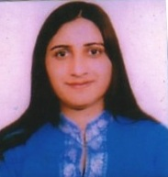

2. Department of Commerce
S. No | Name & Contact Details | Designation | Qualification and Academic Achievements | Photo
1. | Ms. Anshu  anshu.chachra@gmail.com  8398005510 | Assistant Professor | M. Com., M. Phil., NET  Teaching Experience: 4 Years | 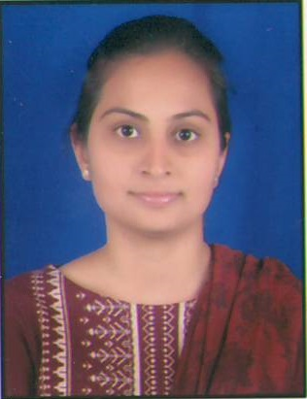
2. | Sh. Ravi Kant  apravi1992@gmail.com  9812222276 | Assistant Professor | M. Com., M. Phil., NET  Teaching Experience: 4 Years | 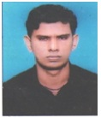
3. | Ms. Seema Rani  seema_saini2007@rediffmail.com  7404139070 | Assistant Professor | M. Com., NET (JRF)  Teaching Experience: 4 Years | 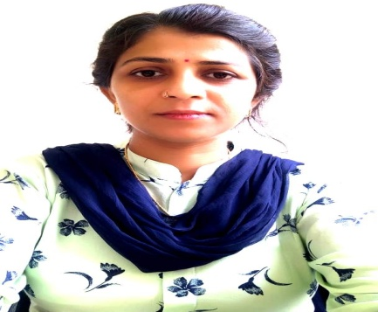
4. | Ms. Ritu Rani  rituyadav80583@gmail.com  7011432507 | Extension Lecturer | M.Com., NET, MBA (Finance)  Teaching Experience: 8 Years | 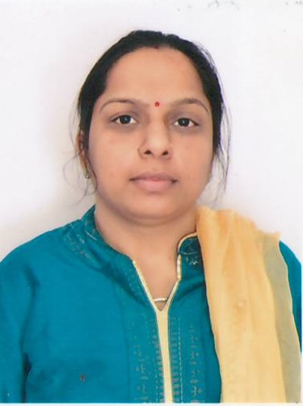

3. Department of Computer Science
S. No | Name & Contact Details | Designation | Qualification and Academic Achievements | Photo
1. | Sh. Hawa Singh  write2hawasingh@gmail.com  9466163931 | Assistant Professor | M.Tech.(CSE), NET  Teaching Experience: 21 Years | 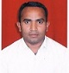
2. | Ms. Pooja Yadav  yadavpooja0628@gmail.com  9050675793 | Computer Instructor | MCA.,  Teaching Experience: 6 Years | 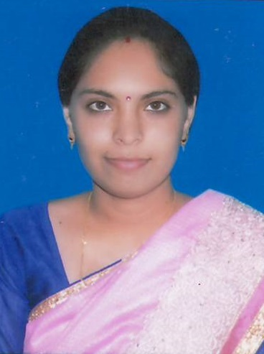

4. Department of English
S. No | Name & Contact Details | Designation | Qualification and Academic Achievements | Photo
1. | Dr. Karan Singh  vikramveer23@gmail.com  9728036361  C.V. is available at https://vidwan.inflibnet.ac.in/profile/172328 | Professor | M.A., M. Phil. Ph. D., NET, SLET  Teaching Experience: 26 Years | 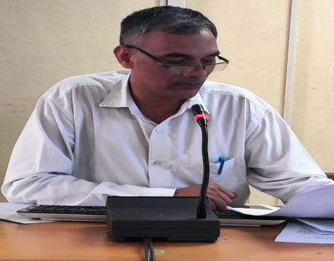
2. | Dr. Jyoti Yadav  jyotikaransinghyadav@gmail.com  9466838100 | Associate Professor | M.A., M. Phil. Ph. D. NET, SLET  Teaching Experience: 22 Years | 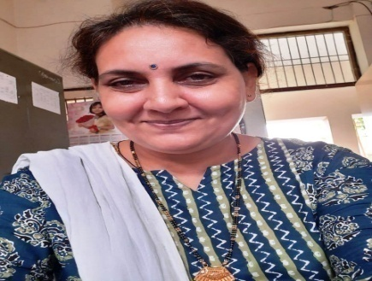
3. | Dr. Sujan Singh  Sujansinghyadav174@gmail.com  8607787031 | Assistant Professor | M.A., Ph. D., NET  Teaching Experience: 6 Years | 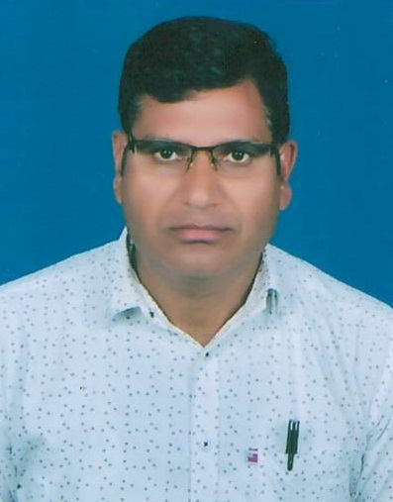

5. Department of Geography
S. No | Name & Contact Details | Designation | Qualification and Academic Achievements | Photo
1. | Ms. Vinita  vinita7899@gmail.com  9050712916 | Extension Lecturer | M.A., NET  Teaching Experience: 7 Years | 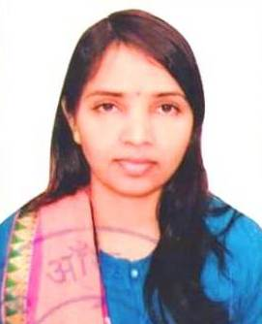

6. Department of Hindi
S. No | Name & Contact Details | Designation | Qualification and Academic Achievements | Photo
1. | Ms. Roshni  roshnidhayal@gmail.com  9671596115 | Assistant Professor | M.A., NET  Teaching Experience: 2 Years | 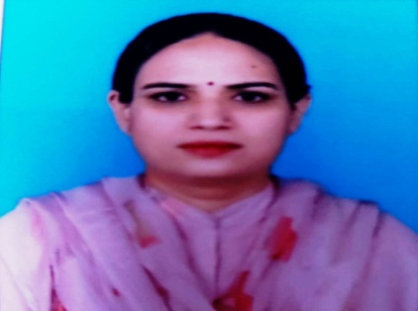

7. Department of History
S. No | Name & Contact Details | Designation | Qualification and Academic Achievements | Photo
1. | Sh. Parmod Kumar  parmodkumar20375@gmail.com  9466332219 | Assistant Professor | M.A., M. Phil., NET  Teaching Experience: 14 Years | 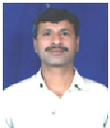

8. Department of Mathematics
S. No | Name & Contact Details | Designation | Qualification and Academic Achievements | Photo
1. | Sh. Sandeep Kumar  sk829872@gmail.com  9541950704 | Extension Lecturer | M.Sc., NET (JRF)  Teaching Experience: 4 Years | 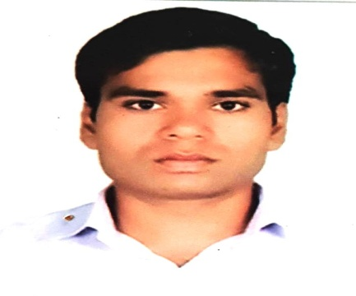

9. Department of Political Science
S. No | Name & Contact Details | Designation | Qualification and Academic Achievements | Photo
1. | Ms. Neelu  neelukishnani@gmail.com  9996880187 | Assistant Professor | M.A., NET  Teaching Experience: 13 Years | 